eBeam Engage

eBeam Engage™ interactive whiteboard device combines more than ten multimedia and navigation tools in one sleek console to make lesson delivery effective and fun.

Key Features
- Plug and play
- Makes lesson delivery fluid
- Puts frequently used tools within arms reach
- Keeps focus and attention on content
- Improves navigation with customizable links to commonly used applications, folders, files and URLs and scroll knob
- Wireless keyboard eliminates need to toggle between computer and interactive surface
- Simple installation requires no special skills or tools – usable on existing surfaces
- Records sound and video in real time with one-touch recording button, built in microphone and line in/out ports
- Provides two built in USB ports to attach additional peripherals to the console

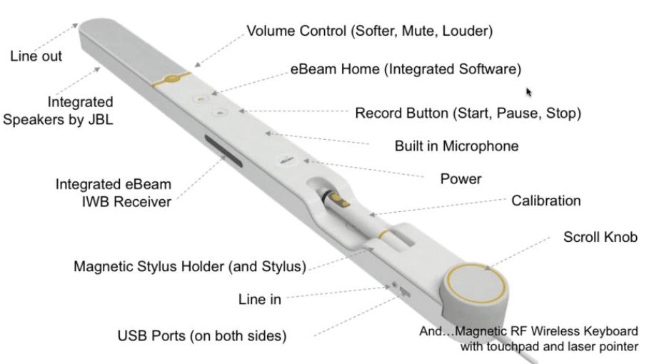

Highlights
Why eBeam Engage?
- Make content delivery fluid by controlling navigation, sound system and recording functions from one console.
Organizational Benefits:
- Quickly and easily install the physically secure eBeam Engage without costly installation or specialized skills or tools.
- Integrate devices using the USB ports and line in/line out audio jacks.
User Benefits
- Create links to commonly used resources with eBeam Home™.
- Access and work with files and applications anywhere, anytime using the wireless mini keyboard with touchpad and laser pointer.
- Use the scroll knob to focus attention on relevant content.
- Encourage student participation without blocking the display area.
- Record and play back high quality audio visual media with built in microphone and speakers.
- Distribute or post recordings so students have the ability to review and reinforce concepts.
eBeam Engage Features
- High Fidelity JBL® speakers
- Built in microphone
- Line in/line out audio jacks
- One touch recording
- Scroll knob
- Wireless (RF) mini keyboard pre assembled with magnetic sleeve
- eBeam interactive receiver
- Multi function stylus
- Customizable eBeam Home
- Software and curriculum resources
- Security key to unlock unit
- 2 Kensington Lock slots
- 2 USB ports

